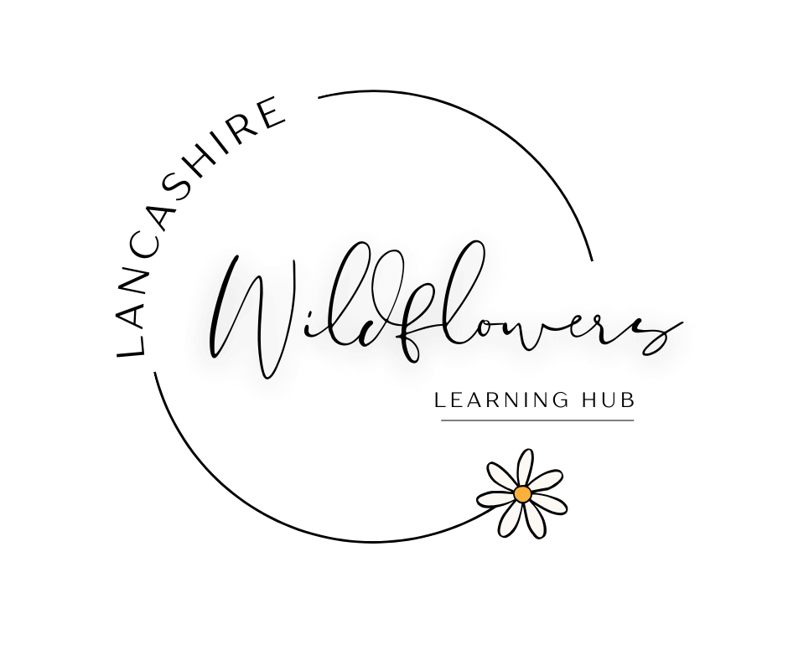
Lancashire Wildflowers Alternative

Provision Ltd - Referral Form

"Growing Hearts, Guiding Futures"

Please complete this form to refer a pupil for a part-time placement at Lancashire Wildflowers Learning Hub. All pupils must remain on the roll of their referring school.

1. School Information
School Name:
School Address:
School Contact Name:
Role (e.g. SENCO / Inclusion Lead):
Email Address:
Phone Number:

2. Pupil Information
Pupil Name:
Date of Birth:
Year Group:
Gender:
Does the pupil have an EHCP?
☐ Yes
☐ No
☐ In assessment
Primary area of need (if applicable):

3. Reason for Referral
Please briefly outline why this pupil is being referred to Alternative Provision:
☐ School anxiety / EBSA
☐ Behaviour concerns
☐ Confidence / self-esteem support
☐ Social or emotional needs
☐ Difficulty accessing mainstream classroom
☐ Reintegration support
☐ Other (please describe)
Additional details:

4. Pupil Strengths and Interests
Please describe the pupil’s interests, strengths, or activities they enjoy. This helps us support engagement.

5. Behaviour and Support Needs
Please outline any behaviour or support needs we should be aware of:
Has the pupil displayed any of the following? (tick if applicable)
☐ Physical aggression
☐ Verbal aggression
☐ Absconding / leaving site
☐ Anxiety / panic attacks
☐ Self-harm concerns
☐ Other (please describe)

6. Safeguarding Information
Are there any safeguarding concerns or relevant background information we should be aware of?
☐ Yes
☐ No
If yes, please provide brief details:

7. Placement Request
Preferred placement days (if known):
☐ Monday
☐ Tuesday
☐ Wednesday
☐ Thursday
☐ Friday
Requested placement type:
☐ 1 day per week
☐ 2 days per week
☐ Short-term intervention placement
Proposed start date:

8. Additional Information
Any further information that may support the pupil’s placement:

9. School Declaration
I confirm that the pupil will remain on the roll of the referring school and that Lancashire Wildflowers Learning Hub will provide a part-time placement only.
Name:
Position:
Signature:
Date:

Please return completed referral forms to:
Gemma Mills
Lancashire Wildflowers Learning Hub
Email: info@lancashirewildflowers.com
Phone: 01772 356027

